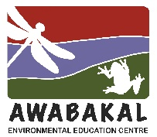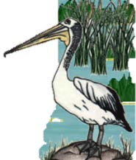
Wet and Wild
2023, Week 4 - Clues
Wet and Wild in a Food Web
Wetlands are biodiverse ecosystems with all the organisms interlinked to form different food webs.
Remember to form a food chain in your answer.

1. Most of my species are tropical varieties that normally grow north of the Tropic of Capricorn.
2. I’m medium-sized with long legs and very long toes that allow me to walk on floating vegetation.
3. I’m olive-brown and white on the underbody, with a black cap, a white face and a large red fleshy comb.
4. I’m non-venomous, but have sharp, backwards-pointing teeth.
5. My nostrils and eyes sit at the top of my head and my sharp teeth are visible when my mouth is closed.
6. Males can grow to 2.5–3.0 m long, while females reach a smaller size of 2.1 m.
7. I’m dark blackish brown to olive-green on the back, with smooth, iridescent scales.
8. I eats seeds and aquatic insects around floating vegetation on the water surface.
9. My round leaves float on water and my stems are up to 30cm long.
10. My flowers are various in sizes and colours.
11. I lay probably the most beautiful eggs of any bird in Australia.
12. I live in and around freshwater rivers, ponds and billabongs but I am also saltwater tolerant.
13. My lower jaw is held together by flexible muscles and ligaments. This allows me to stretch it far apart to swallow large prey.
14. The male alone builds the nest, incubates the eggs and cares for the young.
15. I usually lay between 11 to 22 eggs which the female curls around to incubate.
16. About five days before hatching, the young call from within the eggs. This stimulates adults to open the nest.
17. In Kakadu people eat the stems, the root and the flower head. The stems taste a bit like celery.
18. I usually lie motionless in shallow water and wait but prey such as wallabies and water birds I stalk and ambush.
19. I provide shelter and food for large numbers of insects and their larvae and create an excellent habitat for water birds.
20. If danger threatens, the male can pick the chicks up under his wings and carrying them off to safety.
21. I’m strongly connected to rainbow serpent dreaming in local indigenous cultures.
22. I feed mainly on water birds and their eggs but also eat young crocodiles and mammals.
23. The Cane Toad is causing large numbers of my species to die as it spreads across the Top End.
24. I grow in lakes, billabongs, and wetlands where the bottom is deep mud and the water depth is at least 1 m.

