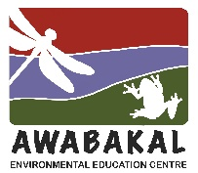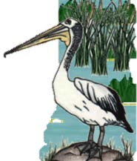
Wet and Wild
2023, Week 3 - Clues
Wet and Wild in a Food Web
Wetlands are biodiverse ecosystems with all the organisms interlinked to form different food webs. Just about every plant and animal is food for something else.
Each week, we are going to have 4 organisms which form a food chain, so there might be a plant, a herbivore, a carnivore and a large carnivore.

1. I can be plant or animal.
2. I am a freshwater, filter feeder.
3. I have a spine coming out of my head.
4. I am a large bug and underwater predator.
5. My common name relates to the colour of my face.
6. I have a long thin neck and a dark, pointed bill.
7. I use a long thin tube attached to my rear end to breathe.
8. I belong to the decapoda family.
9. My long legs allow me to wade through shallow water looking for food.
10. I can be very, very tiny up to a few millimetres in size.
11. I have a transparent exoskeleton, up to 4 cm long.
12. Both parents help to build a nest in a tree and look after the young.
13. When flying, I appear to ‘bounce’ with long, slow-beating wings.
14. I have a fan like tail for swimming and 5 pairs of legs.
15. I float or drift through the sea, freshwater and even air.
16. I produce much of the oxygen that people and animals need to survive.
17. I’m about 70 cm tall and mostly light blue grey in colour.
18. When I am very young, I can be part of the first group in this food chain.
19. My name comes from a Greek word meaning ‘wandering’.
20. I use my 2 pincher-like front legs to catch and carry prey.
21. My common name makes me sound fiercer than I am.
22. I am also the main food for the Whale Shark.
23. My flattened, leaf-shaped body is brown.
24. I live under water but I’m a poor swimmer, I can walk on land but I’m also a strong flyer.

