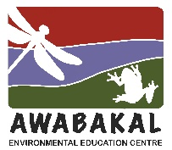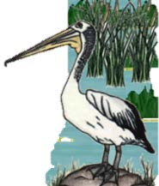
Wet and Wild
2023, Week 2 - Clues
Wet and Wild in a Food Web
Wetlands are biodiverse ecosystems with all the organisms interlinked to form different food webs. Just about every plant and animal is food for something else.
Each week, we are going to have 4 organisms which form a food chain, so there might be a plant, a herbivore, a carnivore and a large carnivore.

1. I have one of the smallest flowers in the world on a tiny, leaf-like body.
2. I have hairy, oar or scoop shaped hind legs I use for swimming.
3. I have an oval, flattened body shape, 3mm to 15mm long.
4. I am a dabbler (tip headfirst into the water) and eat mainly plants.
5. I am a very large, distinctive bird with a wingspan up to 2.2m.
6. I have piercing and sucking, straw-like mouthparts.
7. I float on the water and am native.
8. I have distinctive dark lines on my face.
9. My main threats are competition and hybridization with mallards, habitat loss and hunting.
10. My common name relates to the white of my chest and underpart feathers.
11. I help clean water and can be used as a protein source to feed stock.
12. My main food is fish but will also hunt waterbirds and other small animals.
13. My leaves are about 4mm long and I can grow extremely quickly.
14. I’m 50 to 60cm long and have webbed feet.
15. I grow on still or very slow moving water and can look like a green carpet.
16. My large nest is made of sticks in very tall trees or cliffs near water.
17. Even through my common name has ‘black’ in it, I am mainly brown and have a green on my wings.
18. I can be spread by waterbirds.
19. I do eat small pond organisms but mainly plants.
20. I am the mascot for an Australian rugby league team.
21. My nest is hidden in tall grasses or reeds or even a hole in a tree.
22. I swim right side up, unlike my relative the Backswimmer.
23. Even though I am an aquatic insect, I can fly.
24. When hunting, I fly towards the sun, so my shadow does not alert my prey.

