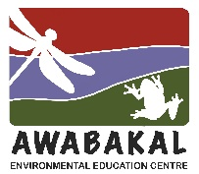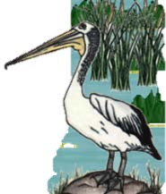
Wet and Wild
2023, Week 1 - Clues
Wet and Wild in a Food Web
Wetlands are biodiverse ecosystems with all the organisms interlinked to form different food webs. Just about every plant and animal is food for something else.
Each week, we are going to have 4 organisms which form a food chain, so there might be a plant, a herbivore, a carnivore and a large carnivore.

1. I have many different shapes and sizes in this group, from single cell to 50m long.
2. I have a hard shell that measures from less than 3 mm up to 30 mm.
3. I look like my terrestrial relations but live in still and flowing freshwater.
4. My skin is very sensitives and permeable.
5. I photosynthesise.
6. I am tall and white.
7. My sticky tongue is attached to the front of my mouth.
8. I have long legs and fold my long neck to fly.
9. I have hundreds of tiny scale like teeth, called a radula.
10. I wade slowly, then often wait motionless to catch my food and spear it with my long, sharp bill.
11. I use my eyes to help me swallow.
12. In a wetland, I provide food for filter feeders, snails and fish.
13. I have a soft body without arms or legs, but I have a foot that produces mucus.
14. I’m a carnivore eating mainly fish.
15. I’m a herbivore.
16. A small number can be toxic and should not be touched by people or animals.
17. I’m an omnivore.
18. The feathers on some species change colour or shape during breeding season.
19. When I ‘bloom’ I can make water appear quite green or brown.
20. I am a gastropod.
21. I have strong back legs.
22. I like to nest in Paperbark and other trees close to wetlands.
23. You can help scientists by recording my calls.
24. I can be a food source, made into bio plastics and used to make energy.

