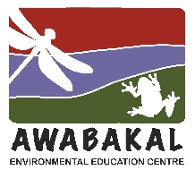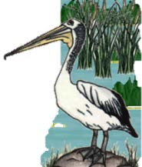
Wet and Wild
2023, Week 2 – Answers
Wet and Wild in a Food Web

Duck Weed, watermeal – Lemna sp. Woliffa sp.
1. I have one of the smallest flowers in the world on a tiny, leaf-like body.
7. I float on the water and am native.
11. I help clean water and can be used as a protein source to feed stock.
13. My leaves are about 4mm long and I can grow extremely quickly.
15. I grow on still or very slow moving water and can look like a green carpet.
18. I can be spread by waterbirds.

Water Boatman – Corixidae sp.
2. I have hairy, oar or scoop shaped hind legs I use for swimming.
3. I have an oval, flattened body shape, 3mm to 15mm long.
6. I have piercing and sucking, straw-like mouthparts.
19. I do eat small pond organisms but mainly plants.
22. I swim right side up, unlike my relative the Backswimmer.
23. Even though I am an aquatic insect, I can fly.

Pacific Black Duck - Anas superciliosa
4. I am a dabbler (tip headfirst into the water) and eat mainly plants.
8. I have distinctive dark lines on my face.
9. My main threats are competition and hybridization with mallards, habitat loss and hunting.
14. I’m 50 to 60cm long and have webbed feet.
17. Even through my common name has ‘black’ in it, I am mainly brown and have a green on my wings.
21. My nest is hidden in tall grasses or reeds or even a hole in a tree.

White Bellied Sea Eagle - Haliaeetus leucogaster or Icthyophaga leucogaster
5. I am a very large, distinctive bird with a wingspan up to 2.2m.
10. My common name relates to the white of my chest and underpart feathers.
12. My main food is fish but will also hunt waterbirds and other small animals.
16. My large nest is made of sticks in very tall trees or cliffs near water.
20. I am the mascot for an Australian rugby league team.
24. When hunting, I fly towards the sun, so my shadow does not alert my prey.

