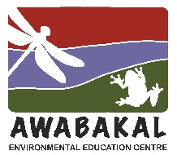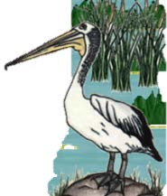
Wet and Wild
2023, Week 1 – Answers
Wet and Wild in a Food Web

Algae
1. I have many different shapes and sizes in this group, from single cell to 50m long.
5. I photosynthesise.
12. In a wetland, I provide food for filter feeders, snails and fish.
16. A small number can be toxic and should not be touched by people or animals.
19. When I ‘bloom’ I can make water appear quite green or brown.
24. I can be a food source, made into bio plastics and used to make energy.

Freshwater Pond Snails
2. I have a hard shell that measures from less than 3 mm up to 30 mm.
3. I look like my terrestrial relations but live in still and flowing freshwater.
9. I have hundreds of tiny scale like teeth, called a radula.
13. I have a soft body without arms or legs, but I have a foot that produces mucus.
15. I’m a herbivore.
20. I am a gastropod.

Frogs
4. My skin is very sensitives and permeable.
7. My sticky tongue is attached to the front of my mouth.
11. I use my eyes to help me swallow.
17. I’m an omnivore.
21. I have strong back legs.
23. You can help scientists by recording my calls.

Egrets
6. I am tall and white.
8. I have long legs and fold my long neck to fly.
10. I wade slowly, then often wait motionless to catch my food and spear it with my long, sharp bill.
14. I’m a carnivore eating mainly fish.
18. The feathers on some species change colour or shape during breeding season.
22. I like to nest in Paperbark and other trees close to wetlands.

