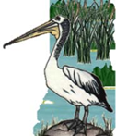

Wet & Wild 2023
Awabakal Environmental Education Centre
Name of school
Name of team

Week number:
(1, 2, 3 or 4)

Name of species | Clue number | Clue number | Clue number | Clue number | Clue number | Clue number

Name of species | Clue number | Clue number | Clue number | Clue number | Clue number | Clue number

Name of species | Clue number | Clue number | Clue number | Clue number | Clue number | Clue number

Name of species | Clue number | Clue number | Clue number | Clue number | Clue number | Clue number

